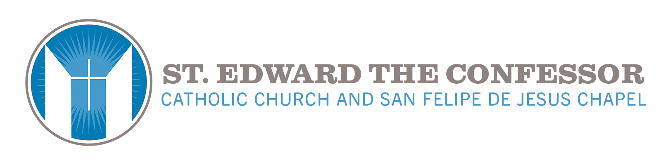
It is highly fitting that Christ should have wanted to remain present to his Church in this unique way. Since Christ was about to take his departure from his own in his visible form, he wanted to give us his sacramental presence; since he was about to offer himself on the cross to save us, he wanted us to have the memorial of the love with which he loved us "to the end," even to the giving of his life. In his Eucharistic presence he remains mysteriously in our midst as the one who loved us and gave himself up for us, and he remains under signs that express and communicate this love.
– Catechism 1380

Adoration of the Most Blessed Sacrament
“The adoration of Jesus in the Most Blessed Sacrament is the end of the Church Militant, just as adoration of God in His glory is the end of the Church Triumphant. A holy rivalry, a concert of prayer, a harmony of divine service should exist between the heavenly court and the Eucharistic court here below, between the adorer and His mother, the Church. Eucharistic Adoration is one of the greatest acts of holiness here on earth. The object of Eucharistic adoration is the divine person of our Lord Jesus Christ present in the most Blessed Sacrament. He is living there. He wants us to speak to him, and he will speak to us. Does he not tell us, "Come you all to me"? The grace of (Eucharistic Adoration) is given to everybody. When your hour is particularly difficult, rejoice all the more; your love will be greater for its suffering more. It is a privileged hour that will count for two. I am fully convinced that if it were humanly possible to fully understand the value of a Holy Hour, everyone would make time to do it. Let us never forget that an age prospers or dwindles in proportion to its devotion to the Holy Eucharist. This is the measure of its spiritual life and its faith, of its charity and its virtue. Until we have a passionate love for our Lord in the Most Blessed Sacrament we shall accomplish little.
Eucharistic adoration is one of the greatest of actions. To adore is to share the life of Mary on earth when she adored the Word Incarnate in her virginal womb, when she adored Him in the Crib, on Calvary, in the divine Eucharist. The Divine King is ever ready to grant us an audience and to admit our souls to the intimacy of his love. Eucharistic Adoration is the most necessary mission to the Church, which has even more need of prayerful souls. The Blessed Virgin is eager to make Jesus in the Eucharist known to all and to group them into a Eucharistic Guard of Honor, a court of devoted adorers. The Eucharist had so powerful an attraction for the Blessed Virgin that she could not live away from it. She lived in it and by it. She passed her days and her nights at the feet of her divine Son.
Among the graces which Jesus gave to His foster-father is that special to an adorer of the Blessed Sacrament. That is the one we must ask of St. Joseph. Have confidence, strong confidence in him. Take him as the patron and the model of your life of adoration. As we grow to know His voice better (in Adoration) and as our hearts become more sympathetic to Him in emptying themselves of what is not him, our Lord manifests Himself in a clearer and more intimate manner... He gives the soul a divine conviction which overshadows the light of human reason.
Jesus Christ in His Sacrament lives the same life of love which consumed Him in His mortal days. In His sacramental state He continues to adore His Father by His depthless self-abasement. He is still the Mediator and Interceder with divine goodness for the salvation of men. Come, let the kingdom of Jesus Christ be established in you! Public Exposition of the Most Blessed Sacrament is God's last grace to man. Eucharistic adorers share Mary's life and mission of prayer at the foot of the Most Blessed Sacrament. It is the most beautiful of all missions, and it holds no perils. It is the most holy, for in it all the virtues are practiced. Today more than ever we have need of men and women who, by their self-immolation, disarm the anger of God inflamed by the ever increasing sins of nations. We must have souls who by their importunity re-open the treasures of grace which the indifference of the multitude has closed. We must have true adorers; that is to say, men of fervor and of sacrifice.
The Church shows to everyone her Bridegroom in the radiant monstrance... Her friends are in adoration and her enemies tremble. Jesus shows Himself to all men; He gives His blessing to the good; He looks on sinners with compassion. He calls them and draws them to Himself. Look upon the hour of adoration assigned to you as an hour in paradise. Go to your adoration as one would to heaven, to the divine banquet. You will then long for that hour and hail it with joy. Take delight in fostering a longing for it in your heart. Tell yourself, "In four hours, in two hours, in one hour, our Lord will give me an audience of grace and love. He has invited me; he is waiting for me; he is longing for me." Adore Jesus in the Divine Host by offering the sovereign homage of your mind to him who is its sovereign truth, of your heart to him who is its God, of your will to him who is its Lord. The great evil of our time is that people do not go to Jesus Christ as to their very Savior and God. They abandon the only foundation, the only law, the only grace of salvation... What is to be done then? We must return to the fountain of life, and not just to the historical Jesus and to the Jesus glorified in heaven, but also to Jesus in the Eucharist. It is necessary to bring him out from the shadows so that he can once again take his place at the head of Christian society. Going to the source, to Jesus, especially Jesus in the Eucharist. That is the mission and glory of our time, so it will be great among the greatest centuries, and saint among the most holy. Adore and visit Jesus, abandoned and forsaken by men in His Sacrament of Love. Man has time for everything except for visits to His Lord and God, who is waiting and longing for us in the Blessed Sacrament. How kind is our Sacramental Jesus! He welcomes you at any hour of the day or night. His Love never knows rest. He is always most gentle towards you. When you visit Him, He forgets your sins and speaks only of His joy, His tenderness, and His Love. By the reception He gives to you, one would think He has need of you to make Him happy.”
by Peter Julian Eymard

Come then and make a special commitment of spending one hour a month consistently, or twice a month, in prayer and meditation as a People of God on the 1st. and/or 3rd. Mondays of the month. The hours are between 9:00 am on Mondays to 8:00 am the next morning, with a 30 minute interruption for the 5:30 pm Mass.
Come to pray at a consistent hour for Vocations to the Priesthood & Religious Life, for your Family, for Peace in our World, and for the many who are in need of prayers.
Come to worship and pray silently to the Heavenly Father with our Eucharistic Lord in the Exposed Blessed Sacrament during our 24-hour Adoration.
Come to a spiritual work full of faith, hope and love – Contemplative prayer. You may contact me, Deana Progar, to sign up for an hour at the above email address.

At this time we are most in need of one more person at the following hours:

1st. Mondays/Tuesdays of the month – 1:00 pm, 6:00 am

3rd. Mondays/Tuesdays of the month – 6:00 pm, 4:00 am, 6:00 am

Adoration of the Exposed Blessed Sacrament was mandated by Bishop Johnson to hold perpetual adoration in the Diocese of Orange, so come and keep Him company so that the Exposed Blessed Sacrament is never left unattended on the Altar.

Contact Deana Progar: dprogar@cox.net

